**INTRODUCTION**

**Background of the Study**

Health informatics harness technology to improve the management, usage, storage, security and exchange of health information across various entities in the community. Community Health Tracker is the software program that manages the transactions, control documents, and tracking the health of the community. Information systems, for instance, can be maximized to increase the timeliness and accuracy of patient care and administration information, increase service capacity, reduce personnel costs, and inventory levels, and improve the quality of patient care (www.healthcare.seimens.com).

In the field of public health and medical informatics, social media is becoming a valuable resource for learning about population health. Social media data can be analyzed to track the spread and prevalence of disease, learn about trends in tobacco and drug use and understand pain and other ailments. While these are promising applications of social media analysis, these applications can depend on knowing the geographic locations of users (Eke, et al. 2011). Through Geo-location API, it can identify and estimate the exact structured location for those affected places. API or the application program interface is a set of routines for building software application. This application provides accurate location information for a large percentage of users and it shows how this information can be used to improve the accuracy of influenza tracking (Lamb, Paul, and Dredze 2013).

The Department of Health at Bunawan, Agusan del Sur, has been facing problems in working manually from monitoring, keeping, searching, and regulating of the documents from the barangay health centers to the municipal health center. They manually manage their documents to the point that it takes time. Every barangay health center in Bunawan has been manually submitting their report to the municipal health center. So, it will take time to finish a certain transaction and also, they manually searching the place for those who are prone by the diseases. As a result, the researchers have come up with the solution to create an application which is the Geolocation- Enabled Community Health Tracker. Having this application will lessen the burden of the admin in daily transaction because it has a feature that will help the health personnel from their offices.

**Objectives of the Study**

This study aims to map out significant diseases happening in the community through geolocation. Specifically, this study aims to:

1. Develop an application that will geotag the location of place infected with epidemic diseases.

2. Design a database of health information of Barangay residents in the municipality of Bunawan, Agusan del Sur, based on indicators to be provided by the Department of Health and barangay health personnel.

3. Develop an application that will generate statistical reports which aid health official’s decisions.

**Significance of the Study**

Developing an application through Geo–location was one way of locating the exact location that is prone by diseases. The result of the study is beneficial to the following:

**Admin** – people employed and assigned at the municipality health center.

**Users** – health personnel of each Barangay health center.

**Scope and Delimitation**

This study focuses on the tracking of health and finding geographical location for those places that are infected with the diseases at the municipality of Bunawan, Agusan del Sur through geo – location.

**Time and Place of the Study**

This study will be conducted in the Health center of municipality of Bunawan, Agusan del Sur from April 2018 to March 2019.

**Operational Definition of Terms**

**Application** a platform that the researchers used.

**Computer** is an electronic machine used by the personnel.

**Database** the collection of gathered data.

**Data** refers to the documents of information being stored in the database

**Geolocation** is the identification or estimation of the real-world geographic location of an object.

**Record** refers to the format documents to be stored processed by the computer.

**Tracker** is a device that follows and records the movements of someone or something.

**Conceptual Framework**

* Monitoring of submitted documents
* Easy way of finding documents
* Easy way of finding some places that are infected by the diseases.

|  |
| --- |
| Output  Input   * Username & Password * User’s Information * Documents   Information |

|  |
| --- |
| Process  **Geolocation- Enabled Community Health Tracker Application** |

Figure 1.0 Conceptual Framework of the System

This conceptual framework shows all the transactions of Community Health Tracker App. This app will provide the basic functions or process of the application. This will see the output of this application to monitor the records or data and easy way of finding the exact location.

**REVIEW OF RELATED LITERATURE**

**“Clinical application of the Omaha system with the Nightingale Tracker: a community health nursing student home visit program”**

According to Rockville Pike, Bethesda MD, 2015, the application of computer use in the clinical and educational arena needs to be emphasized for both the improved management of patient data and nursing knowledge. Faculty commitment to automation of home visit documentation records was essential to sustain the trial of implementing the Nightingale Trackers in the clinical area. The Nightingale Tracker is a software program that automates the Omaha system, a community-friendly nursing language that encourages a focus on health promotion. A team approach involving students, faculty, and technical support enabled the automation of the patient record of a home visiting program in a community health nursing course.

**“Lively Data, Social Fitness and Biovalue: The Intersections of Health Self-Tracking and Social Media”**

The intersections between self-tracking for health and medical purposes and social media. The expanded array of digitized devices that are available for self-tracking and the capacity of many of these technologies to interact with social media platforms have encouraged self-trackers to share the details that they collect about themselves with others. Begin with a

description of self-tracking and the socio material theoretical foundations on which the chapter rests. This is followed with an overview of the technologies that are available for health and medical self-tracking and for self-trackers to share their data (<https://ssrn.com/abstract=2666324>).

**“Community Health Information Resource Guide”**

This resource guide contains useful information for those who would like to use data to assess the health status of an Indiana community. Targeted users include local organizations such as county health departments and community health coalitions. Being able to access and use relevant data and information resources is a common hurdle for those interested in assessing and advancing community health. As a result of this need and at the request of the Community Advisory Council of the Community Health Engagement Program, we are developing this resource guide to assist individuals, organizations, and coalitions in Indiana in identifying appropriate resources that guide their community health research and evaluation activities.( M., Seyffarth, C., & Thomaskutty, C. June 2014).

**"Open Source Geospatial Health Symptoms Tracker on Android Using Extreme Programming Techniques"**

The benefits of Extreme Programming, Continuous Delivery and other linked methodologies through the development of a solution that aims to help patients track their symptoms when they happen and share them with their doctors to help refine their diagnosis. We learned about methodologies and practices that allow the production of good quality code. In our opinion this is something that is not enough taught at university where the final result of a project is often evaluated regardless of the quality of the code. The solution is composed of four components. First, a mobile application used by patients to record their symptoms and share them with their doctors. Then, a website used by doctors to consult reports of their patients. Next, a backend to collect symptoms, analyze data, send emails and more. Finally, a utility chatbot used to simulate patients and automatically deploy the backend whenever a new version was available (Université catholique de Louvain, 2017).

**“Self-Tracking Modes: Reflexive Self-Monitoring and Data Practices”**

The concept of ‘self-tracking’ (also referred to as life-logging, the quantified self, personal analytics and personal informatics) has recently begun to emerge in discussions of ways in which people can voluntarily monitor and record specific features of their lives, often using digital technologies. There is evidence that the personal data that are derived from individuals engaging in such reflexive self-monitoring are now beginning to be used by actors, agencies and organizations beyond the personal and privatized realm. Self-tracking rationales and sites are proliferating as part of a ‘function creep’ of the technology and ethos of self-tracking. The detail offered by these data on individuals and the growing commodification and commercial value of digital data have led government, managerial and commercial enterprises to explore ways of appropriating self-tracking for their own purposes. In some contexts, people are encouraged, ‘nudged’, obliged or coerced into using digital devices to produce personal data which are then used by others ([http://dx.doi.org/10.2139/ssrn.2483549](https://dx.doi.org/10.2139/ssrn.2483549)).

**“CON Tracking Report”**

The Georgia Department of Community Health (DCH) is one of Georgia’s four health agencies serving the state’s growing population of almost 10 million people.  Responsible for a $12 billion budget for State Fiscal Year 2014, the department is one of the largest agencies in Georgia state government. Serving as the lead agency for Medicaid and also overseeing the State Health Benefit Plan (SHBP), Healthcare Facility Regulation and Health Information Technology in Georgia, DCH’s programs provide access to health care services for one in four Georgians.

Through effective planning, purchasing and oversight, DCH provides access to affordable, quality health care to millions of Georgians, including some of the state’s most vulnerable and underserved populations. Five enterprise offices support the work of the agency’s four programs, with more than 600 DCH employees based in Atlanta, Cordele and across the state. (Frank W. Berry 2014).

**“Compact GPS tracker and customized mapping system”**

Modern technology has brought us the ability to monitor and track movements of persons over geographic areas by use of monitoring devices that utilize the Globally Positioned Satellite System or (“GPS”). GPS is a position/navigation system that consists of a constellation of 28 satellites. A GPS receiver is an electronic device that receives signals from the satellites

to determine its location on earth, in any weather. GPS has been around since the early 1980s and has been fully operational for many years now.

In any GPS device used by the civilian population corrections are made to adjust the vertical error inherent in the GPS signal. The US government adds a variable to the mix of data transmitted from the satellites so that no one can download immediate precise accurate information. Typically, this technology is used by the civilian population in motorized vehicles to assist in determining where that vehicle is located geographically ( Eshenbach, U.S. Pat. No 5,798,732).

**“Validity of the *Fitbit* activity tracker for measuring steps in community-dwelling older adults”**

Physical inactivity is a major risk factor for many chronic conditions, and contributes to early mortalityand rising healthcare costs.Although prevalent throughout the lifespan, physical inactivity and sedentary behavior (time spent sitting and lying down) are particularly common among older adults. Health problems that are more common in older age may also contribute to low physical activity levels.

Pedometers quantify and give feedback on physical activity and this increases physical activity levels.The Fitbit tracker (Fitbit Inc, San Francisco, California, USA) is a relatively affordable commercially-available pedometer that automatically records step counts and can provide instant feedback on either the device itself or via simple software accessed via the internet. Fitbit trackers come in a variety of small unobtrusive activity monitors that can be clipped onto a belt, attached to clothing or worn around the wrist (Lancet 2013; 380:219–29).

**“iSERVE- An Android Based Artificial Intelligence Emergency CP(Crime Prevention) Response System Using GPS Tracker”**

Disasters, natural or human-induced hit the country every now and then. This usually results in the tremendous destruction both to life and property. And because of this need, a functional and action-oriented system which will let people have to communicate in times of disaster is very important. There are different emergency handling services that are present until now to lend a hand the various types of emergencies faced in present. DRRM (Disaster Risk Reduction Management) is one of the organizations that helps, scattered different disaster issues.

Disaster at times hit, wherein communication is very hard, and longer available when utmost it is needed. Go-anywhere applications support a wide array of social, financial, and enterprise services for any user with a cellular data plan. Mobile devices are increasingly becoming an essential part of human life as the most effective and convenient communication tools not bounded by name and place. The research is intended to construct a system that provide timely access to comprehensive, relevant, and reliable information that is critical to humanitarian operations, as well as operations management, this also include the automatic update of news online specially on social medias. The objectives of the system is to implement the artificial intelligence using the GPS Tracker android phone; to provide reliable and comprehensive help for the community that is in tragedy; to help various organizations leading to the disaster risk reduction management; to utilize the GPS tracker feature of android device ( J. Fajardo and C. Oppus 2010).

**Australian Capital Territory (ACT) Medicare using GPS**

In early 2015, Comcare in conjunction with the Australian Capital Territory (ACT) Medicare local, plan to pilot the introduction of a ‘certificate of capacity’ for a small number of GPs within the ACT followed by a gradated general introduction to other practitioners within the territory. This certificate of capacity is designed to take the place of both the traditional medical certificate and also workers compensation certificates. This project proposes undertaking a survey of the attitudes of GPs within the ACT to health and work both in the period shortly after the introduction and also in the period following. As noted, this parallels other research tracking the GPS perception of health and work and also their response following the introduction of the certificate of capacity (Department for Work and Pensions, 2013).

**“Wearable Activity Tracker”**

Engaging in regular physical activity (PA) has numerous benefits. Exercise can help control weight, reduce risk of certain diseases and cancers, improve physical, physiological, and mental health, and even increase life expectancy. Nevertheless, nearly one in four adults in the United States fails to achieve weekly PA and over two thirds are now considered overweight or obese. Members of the U.S. Armed Forces are not immune to these challenges; indeed, overweight and obesity rates among active duty service members have come to resemble those of the general population. Given the military’s history of stringent physical fitness requirements, these findings have implications for the recruitment, health, readiness, and retention of the warfighter. In 2013, the U.S. Defense Health Board (DHB) reported on military obesity trends and the overall health and fitness of the Force. In their conclusions, they recommended the Department of Defense “develop and promote technology-based approaches to improved fitness”. In addition, the DHB suggested interventions targeting military health and fitness should “incorporate exercise, healthy eating information, good sleep hygiene, behavioral modification, self-monitoring, relapse prevention, and structured follow-up by trained personnel. (Dixon, P. M. 2016).

# “Tracking health commodity inventory and notifying stock levels via mobile devices”

Reliable availability of health commodities is fundamental to diagnosing and treating illnesses in primary healthcare settings. Health commodities include health products, health and medical supplies, and other items that may be needed for the provision of health services, including medicines, vaccines, medical supplies such as contraceptives dressings, needles and syringes, and laboratory/diagnostic consumables. The World Health Organization Global Strategy for Women’s and Children’s Health highlights the importance of equitable access to life-saving medicines and other health commodities. A hallmark of functioning health systems is the availability of essential medicines in adequate amounts, appropriate dosage forms, assured quality, and at a price that is affordable for the local community. However, stock-outs of critical medical commodities, such as medicines, are widespread especially in low and middle income countries. Lack of access to medicines and other health commodities is often symptomatic of broader systemic problems. For example, access to medicines is determined by rational use of medicines, affordable pricing, sustainable financing, and reliable health and supply systems. A reliable medicine supply system must comprise of appropriate procurement and distribution. A good distribution system ensures timely availability of medicines across all levels of the healthcare system and prevention of stock-outs. (Organization of Care EPOC December 2017).

**“Tracking the Path of Communities of Inquiry in TEFL”**

# The community of inquiry is a techno-pedagogical framework that has gathered significant attention in online education research. It has been implemented in diverse disciplines, (foreign) language learning being one of particular interest for the authors of this paper. Due to the dynamics proposed by the framework, it appears as a practical and relevant option to generate a successful learning experience for English as a Second or Foreign Language learners. Therefore, this article provides a brief description of the model, its theoretical foundation, its applications and potential uses in the area of language learning in online environments. (González Miy, D., & Herrera Díaz, L. E. 2015)

**“Criteria for Assessing the Usefulness of Community Health Assessments”**

Community health assessments (CHAs) are a means of identifying and describing community health problems, gaps and strengths in services, and interventions to improve the health of the community. To inform the development of a Web-based tool to determine and enhance the usefulness of CHAs, we performed a literature review of various studies and publications to identify factors and criteria for a useful CHA process. We found no rigorous, systematic reviews of CHAs, nor any comprehensive summaries of CHA strengths, weaknesses, and outcomes. However, we used this opportunity to review descriptive reports of a number of CHA processes throughout the United States and to learn about common—and not so common—characteristics that might be used in the Web-based tool. (Dutchess County’s 2014).

**“Australia’s Health Tracker”**

The burden of chronic diseases is a major public policy challenge that threatens the health of individuals and communities and Australia’s future economic prosperity. We have an unacceptably high rate of risk factors for chronic diseases, including obesity, physical inactivity, alcohol misuse and poor nutrition. Action is urgently required in relation to modifiable risk factors that contribute to disease and disability in Australia. This paper proposes a set of national chronic disease targets and indicators as a means of measuring progress and enhancing accountability for action. Chronic diseases are responsible for nine out of ten deaths in Australia. Many Australians living with chronic diseases such as diabetes, mental illness and cancer, experience reduced quality of life and disability over many years. Chronic diseases result in a significant economic burden because of the combined effects of healthcare costs and lost productivity. It has been estimated that eliminating chronic diseases could increase the workforce by 10 per cent and boost the productivity of the Australian economy correspondingly (Business Council of Australia 2013).

**METHODOLOGY**

**Software Process Model**

The researchers decided to use the Modified Waterfall software process model because it is a conceptual model used in project management that describe the stages involves in an information system development project from initial feasibility study through maintenance of completed application. Also explained that a user proceeds a sequence in phases from the definition of deficiencies of the existing system, defining new system requirements, analysis and implementation.

**Modified Waterfall Model**

Requirements Definition

System and Software Design

Implementation and Unit Testing

Integration and System Testing

Operation and Maintenance

Figure 2 Waterfall Significance

1. ***Requirements Analysis and Definition.*** It is one of the important stages in developing of our application which is the Geolocation-Enabled Community Health Tracker. The process that has been done in this stage is first, find all the information about the current system in finding the information and some research has been done.
2. ***System and Software Design.*** In this phase, the researchers construct the appearance of the entire system. The first things that have been made for this stage is about the current system that center have been used. There are eleven users that can use the system. It is the admin, and the ten barangays covered by the municipality of Bunawan, Agusan del Sur. Personnel of each barangays centers can manipulate data and generate the report for viewing or reference. It will easier to the administrative management for updating the data and makes it as reference.
3. ***Implementation and Unit testing.*** During this phase, the researchers already realize the programs or unit of programs as it is verified that the system meets the specification.
4. ***Integration and System Testing.*** Units or programs are integrated and tested as a complete system to ensure that the software requirements have been met and it was implemented at Health Center in Bunawan, Agusan del Sur.
5. ***Operation and Maintenance.*** The researchers will correct the errors of system which will not be discovered in earlier phases of the life Cycle. Improvement and implementation of system and enhancing the system’s services shall be rendered completed.

**Requirements Specification**

**User Requirements**

* Every user should have their own identification
* Log in facility
* Admin, and the users of each barangay which is the health personnel can update the uploaded documents

**Functional Requirements**

* An application that aims to improve the submission of Department of Health in Bunawan Health Center documents.
* The admin and the health personnel who are the users of each barangay are the major functional requirements in the application.
* The admin and the health personnel who are the users of each barangay can upload and update the documents found or file that has been submitted to the applications.
* The admin has an important role since they are one who can give restrictions to every user.
* This application will help the admin aid to locate the place that are infected by the diseases and also accommodate the other health personnel of barangay.

**Non- Functional Requirements**

* **Operational Requirements**
* The application that will organize in managing the files and documents and can locate the place those are infected by the epidemic diseases.
* **Performance Requirements**
* The program is easy to use with.
* **Security Requirements**
* Security is highly needed.
* There are various categories of people the name, age, gender of the patient and etc.
* Only the admin can notify the documents.

**System Requirements**

**Hardware**

The researchers designed an application for Bunawan Health Center: Geolocation- Enabled Community Health Tracker application and can be implemented on a computer with the hardware specification.

* Computer system

**Software**

* Java
* MySQL Database
* Xamp V3.2.2
* Sublime

**Feasibility Issues**

**Technical Feasibility**

The technical resources needed to develop the system are the java as a programming language used by the proposed study, MySQL Database, Xamp V3.2.2 and Sublime. The application is embedded with password and accession of unauthorized person is presented as a security of the records.

**Economic Feasibility**

It is more commonly since it is less expensive to meet the software requirements by the office. And it will help the health personnel for locating those places that are prone by the diseases. The one time cost or recurring cost should not exceed the benefits of the application.

**Operational Feasibility**

The implementation of the Geolocation- Enabled Community Health Tracker application will help the admin as long as the user in producing secure and consistent information.

**Schedule Activities**

Table 1: Schedule Activities of Geolocation – Enabled Community Health Tracker for Municipality of Bunawan, Agusan del Sur using Modified Waterfall Model.

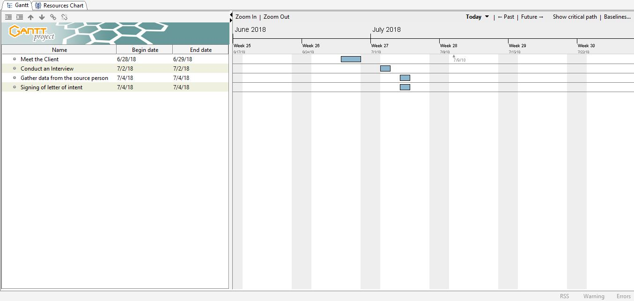

**Project Cost**

**Work Breakdown Structures**

Table 2. Work Breakdown

|  |  |  |  |  |  |  |
| --- | --- | --- | --- | --- | --- | --- |
| Task no. | Activities | System Analyst (400/day | Grammarian /English critic (400/day) | Duration | Cost per activity | Total cost per stage |
| 1.0 | Interview |  |  | 1 day | P 200 |  |
| 1.1 | Data Gathering |  |  | 30 days | P 300 |  |
| 1.2 | Research |  |  | 2 weeks | P 1,000 |  |
| 1.3 | Documentation |  |  | 1 week | P 500 |  |
| 1.4 | Checking of Document |  |  | 2 day | P 100 |  |
| 1.5 | Document critic |  |  | 2 days | P 100 |  |
| 1.6 | Preparation for outline defense |  |  | 1 day | P 500 |  |
| 1.7 | Outline Defense |  |  | .5 day | P 400 |  |
| 1.8 | System and Software Design |  |  |  |  |  |

**Cost Benefits Analysis**

**Project Cost Estimation**

The Cost Estimation is an important consideration in creating a project. The table shows the cost estimation on the implementation and application.

Table 3: Project Cost Estimates

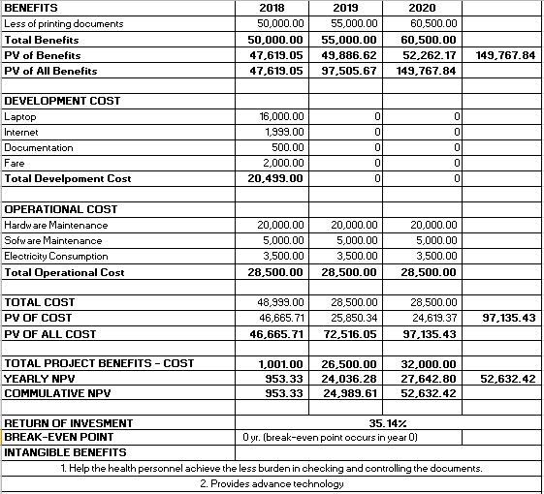

**Risk Management**

This risk management made by the researchers is an essential tool when working a study like this. It can help the researchers to identify and understand the risks that they face in their roles during the study. Moreover, it allows the researchers to draw on detailed information about project plans, financial crisis, withdrawal of team member, and other relevant information.

**Risk Analysis**

Table 4: Possibly encounter the following during the operation of the application.

|  |  |  |  |  |  |  |
| --- | --- | --- | --- | --- | --- | --- |
| Risk | Level | Description | Potential  Indicators | Effects | Strategy | Status |
| Risk 1: No electric power | High | Black out | When the system running out battery low | The pc or system has a limitation to use according to their battery percentage | Generator |  |
| Risk 2:  System Failure | High | When the system cannot follow the exact process of the operation in the meantime. | When the output is not correct. | The developer need to go back in the beginning then the system is disabled to use. The project is deliverables and completion maybe late due to additional tasks. | The team will try to fix the system failure, make consultation to their thesis consultant or create an advance solution for any possible risk. |  |
| Risk 3: Database Failure | High | The data can’t save and find. | When the database can’t work properly | Scattered data files or lost data | Investigate the possibility of buying a higher-performance database |  |
| Risk 4: Staff illness | Medium | Experienced staff will leave the project before it is finished. | When the staff is absent. | It might affect the management of the clinic. | Recognize team so that there is more overlap of work and people therefore understand each other’s jobs. |  |

**Implementation Plan**

**Team Building Activities**

Before the team engaged in making this application, they made steps and some discussions as part of the planning. The team met first the one of the health personnel of the health center to get data and did some interview. After, they did their task with their adviser for consultation about what is the progress of the project and about the documentation.

**Programming, Compilation and Linking**

Beginning of the programming phase and designing the system, then continue until the system will be successfully done.

**Structure Walk Through and Quality Control**

The quality control of the system will be ordered to conduct and gather data for the functions of different tasks assigned by the users. The system was already updated and corrections were made by the panel for maintaining the functionality of the system.

**Testing and Debugging**

Testing and Debugging of the system will be done through the consultation of the adviser, as well as to the chairman. The system will use Xamp V3.2.2 and Java in creating codes to run the system functionally.

**System Documentation**

The system documentation served as a record of the whole system. It was the important in making a hard copy so that there will be a guide for the researchers for the improvement in creating the system.

**System Installation**

When the project is successfully completed, the user may install it to their computer to run the application.

**Periodic Maintenance**

The group will made the user’s manual to discuss on how to use the system. Discuss on how to use the system in order to familiarize the different transaction of the users and feature of the new system.

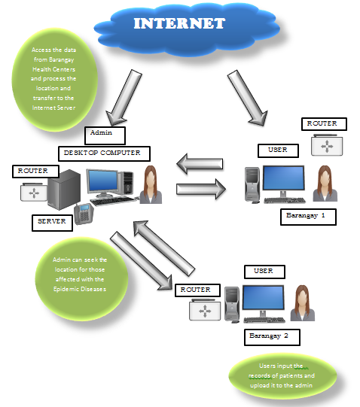

Figure 3. Deployment Diagram

This diagram is used to describe the physical components of the system that being used in the study and also the flow of it. Deployment diagram can be visualized as the components or nodes on which the software components reside.

**LITERARTURE CITED**

Abraham, C., & Michie, S. (2008). A taxonomy of behavior change techniques used in interventions. Health Psychology, 27(3), 379– 387. doi:10.1037/0278-6133.27.3.379 Bai, Y., Welk, G. J., Nam, Y. H., Lee, J. A., Lee, J. M., Kim, Y., . . . Dixon, P. M. (2016).

Alyson Ann Kelvin: 03 July 2016: Immune Diagnostics and Research (IDR), Toronto, Ontario, Canada: February2016:David BannerExperimental Therapeutics, University Health Network, :[http://vuir.vu.edu.au/31085/1/australias-health-tracker- technical- appendix.pdf](http://vuir.vu.edu.au/31085/1/australias-health-tracker-%09technical-%09appendix.pdf)

Berner ES, Detmer DE, Simborg D. Will the wave finally break? A brief view of the adoption of electronic medical records in the United States. J Am Med Inform Assoc 2013;12:3–7

[Christine Peeters](https://patents.google.com/patent/US20090125327A1/en);[Catherine Lazatin](https://patents.google.com/patent/US20090125327A1/en);[Kaushik Patel](https://patents.google.com/patent/US20090125327A1/en): [2007-11-08](https://patents.google.com/patent/US20090125327A1/en): Department of Agriculture, Center for Nutrition Policy and Promotion: <https://patents.google.com/patent/US20090125327A1/en>

David McMinn:January23, 2013 School of Medicine and Dentistry, University of Aberdeen: <https://dl.acm.org/citation.cfm?id=2851685>

Dutchess County’s 2005-2014 Community Health Assessment document is available online: [http://www.co.dutchess.ny.us/CountyGov/Departments/Health/H D ComHealthAss essment05.pdf](http://www.co.dutchess.ny.us/CountyGov/Departments/Health/H%09D%09ComHealthAss%20essment05.pdf).

DC Hazel Hiza, PhD :March 2004:Education, and Extension Service, Washington,Department of Agriculture, Center for Nutrition Policy and Promotion, Alexandria, VA:[https://www.cnpp.usda.gov/sites/default/files/myplate_miplat o/ JNEBGEM427.pdf](https://www.cnpp.usda.gov/sites/default/files/myplate_miplat%09o/%09JNEBGEM427.pdf)

Derek Scissors: February 22, 2010:Former Senior Research Fellow:Derek is a former Senior Research Fellow:<https://dl.acm.org/citation.cfm?id=1141326>

Elliott, T., et al. A systematic interim assessment of the Australian government’s food and health dialogue. Med J Aust 200, 92-95 (2014).

Rohit Goyal:February2016:The Department of Health:Educators; [http://vuir.vu.edu.au/31085/1/australias-health-tracker- technical- appendix.pdf](http://vuir.vu.edu.au/31085/1/australias-health-tracker-%09technical-%09appendix.pdf)

Sloan, Helen L. DNS, RN, CS; Delahoussaye, Carolyn P. DNS, RN Nurse Educator: [January-February 2003 - Volume 28 - Issue 1 - p 15- 17](https://journals.lww.com/nurseeducatoronline/toc/2003/01000):Department of Agriculture, Center for Nutrition Policy and Promotion, Alexandria, VA E-mail: [wenyen.juan@cnpp.usda.gov](mailto:wenyen.juan@cnpp.usda.gov)

Shirley Gerrior, PhD, RD, LD, U.S. Department of Agriculture, Cooperative State Research: [https://melsatar.blog/2012/03/15/software- development-life- cycle-models-and-methodologies/](https://melsatar.blog/2012/03/15/software-%09development-life-%09cycle-models-and-methodologies/)

**APPENDICES**

**CURRICULUM VITAE**



**Personal Information**

Name: Ruffa Mongcal Farofaldino

Nickname: “apple”

Birthday: March 21, 1998

Address: Purok 1, Cahian, Kapatungan, Trento, Agusandel Sur

Father’s Name: Gabriel F. Farofaldino Sr.

Mother’s Name: Rowena M. Farofaldino

Motto: “Don’t tell God how big is your problem, but tell your Problem how big is your God”

**Educational Background**

Elementary: Cahian Elementary School

Secondary: Kapatungan National High School

Tertiary: Agusan del Sur State College of Agriculture and Technology (ASSCAT)

**Seminar and Training Attended**

* PSITE 2018 (Caraga State University, Ampayon Butuan City)

**CURRICULUM VITAE**



**Personal Information**

Name: Shella Mae C. Hisugan

Nickname: “Cha-cha”

Birthday: August 7, 1998

Address: Salvacion, Bayugan City

Father’s Name: Bernardo G. Hisugan

Mother’s Name: Lilia C. Hisugan

Motto: “Believe with all your heart that you will do what you were made to do”

**Educational Background**

Elementary: Salvacion Central Elementary School

Secondary: Salvacion National High School

Tertiary: Agusan del Sur State College of Agriculture and Technology (ASSCAT)

**Seminar and Training Attended**

* PSITE 2018 (Caraga State University, Ampayon Butuan City)